1-How can we make a latch using NOR gates?

2-If A=B=0 what will happen to this latch?

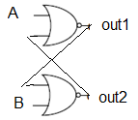

3- If A=1 and B=0 what will happen to this latch?



4- Right or wrong?



A=RESET and B=SET

5- Explain this Table:

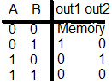We don’t like A=B=1

6-How can we make a Fip Flop using NOR gates and AND gates?

7-If A=B=0 what will happen to this latch? CK=0

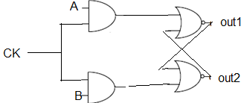

8- If A=1 and B=0 what will happen to this latch? CK=1



9- Right or wrong? This is a high level triggered RS Flip Flop:



10- Explain this Table: This Truth table belongs to which kind of flip flop?

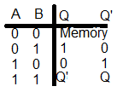

11- Right or wrong? This is a high level triggered RS Flip Flop:

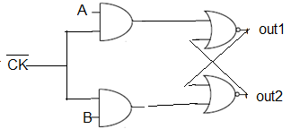

12-Design a Rising edge triggered RS flip flop.

13-Design a Falling edge triggered RS flip flop.

14-Why you can’t buy a T-Flip Flop?

15- Design a D flip flop.

1. level triggered B) Edge triggered